(40 points): Create a Windows Forms application named Question2 to add a new ship.
- User Interface (10 points)
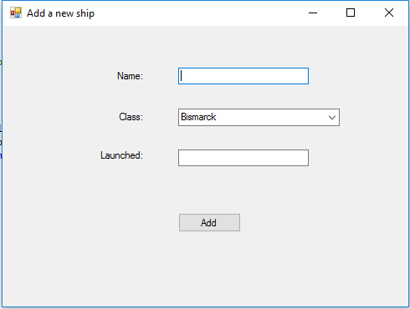
Requirement:
- Bind data of class names of table “classes” to Combobox control. Order data by class name (5 points).
- Event “Click” of “Add” button (30 points)
- Validate (10 points, 5 points for each message)
  - Textbox “Name” must not be empty and must be unique, otherwise one of the following messages will be displayed
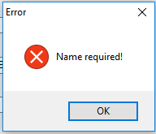

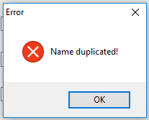

  - Textbox “Launched” must be integer from 1900 to current year, otherwise one of the following messages will be displayed
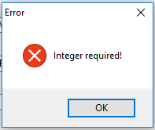

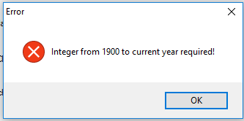
.
- Add a new ship (20 points)
  - Add a new ship with the given information (15 points)
  - Display a message (5 points)
